SQL Real Steel

## Round 1 – ‘Kid’ mode

Write DML queries for the following questions

1. Display unique Jobs from EMP table

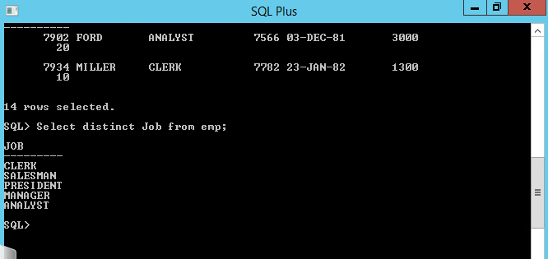

1. List the employees in the ascending order of their salaries

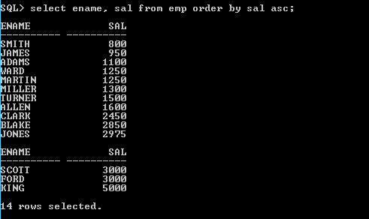

1. List the details of the employees in ascending order of the dept no and descending of Jobs

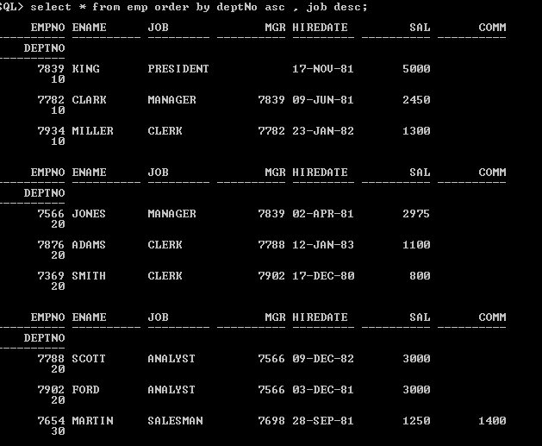

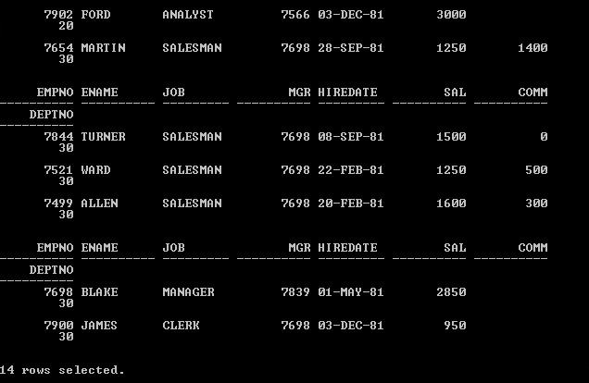

1. Display all the unique job groups in the descending order



1. Display all the employees who are managers

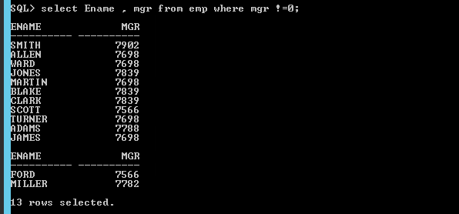

1. List the employees who joined before 1981

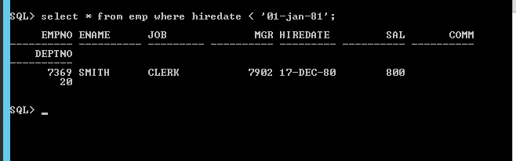

1. List the Empno, Ename, Sal, daily sal of all employees in the ascending order of annual sal

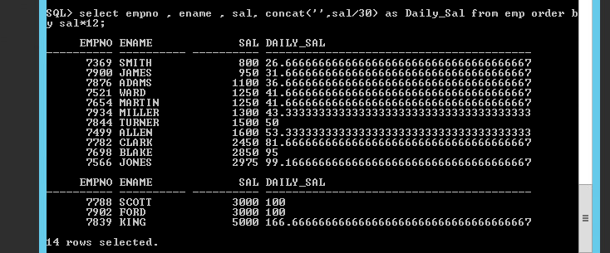

1. Display the Empno, Ename, job, Hiredate, Exp of all Mgrs

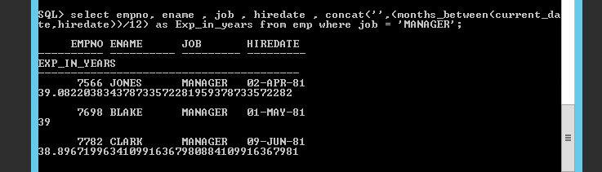

1. List the Empno, Ename, Sal, experience of all employees working for Mgr=7369

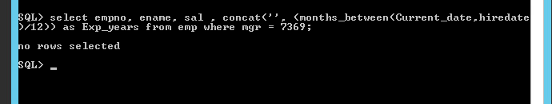

1. Display all the details of the employees whose Comm. Is more than their Sal

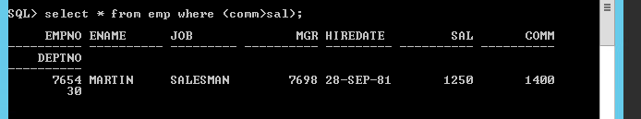

1. List the employees in the asc order of Designations of those joined after the second half of 1981

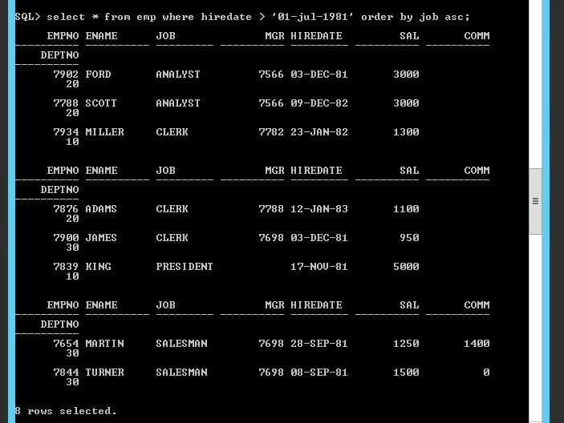

1. List the employees along with their experience and daily salary is more than Rs.100

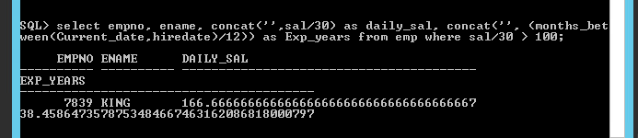

1. List the employees who are either ‘CLERK’ or ‘ANALYST’ in the Desc order

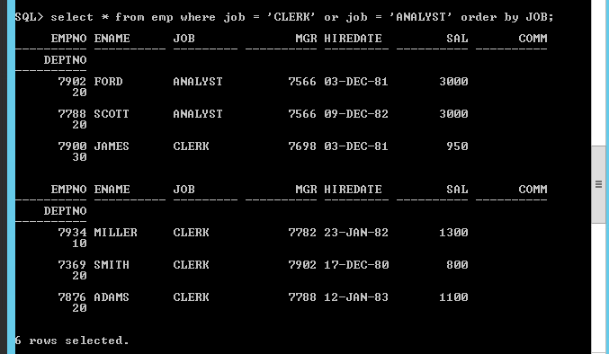

1. List the employees who joined on 1-MAY-81,3-DEC-81,17-DEC-81,19-JAN-80 in asc order of seniority

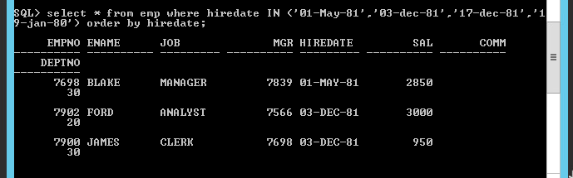

1. List the emp who are working for the Deptno 10 or 20

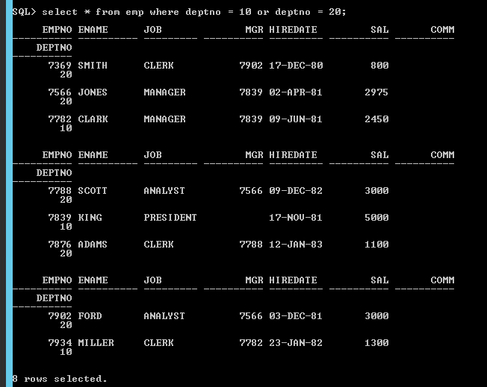

1. List the employees who are joined in the year ‘81

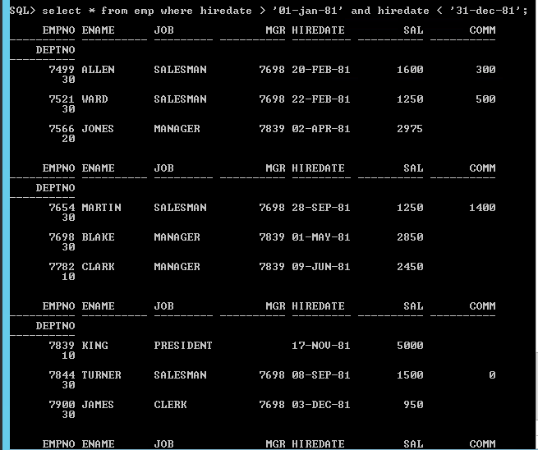

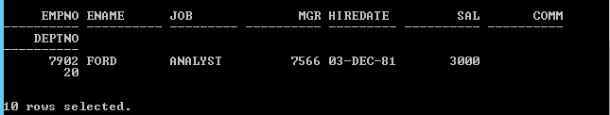

1. List the employees who are joined in the month of Aug 1980



1. List the Enames those are having five characters in their Names

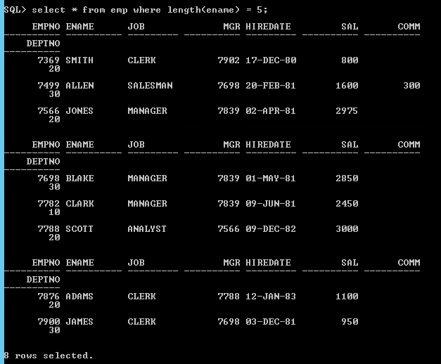

1. List the Enames those are starting with ‘S’ and with five characters

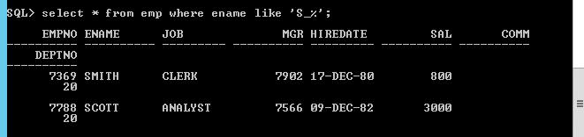

1. List the employees those are having four chars and third character must be ‘r’

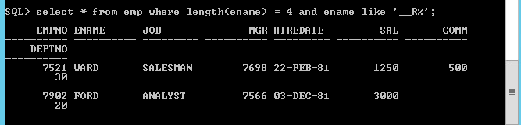

1. List the names of those employees whose employee numbers are 7369, 7521, 7839, 7934, 7788.

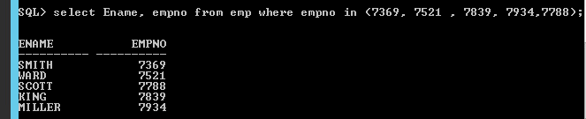

1. List those employees who do not belonging to department 30, 40, or 10

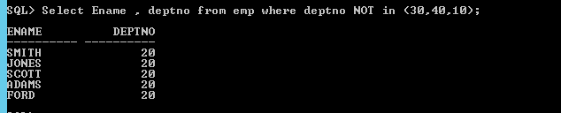

1. List those employee names who have joined between 30 June and 31 Dec ‘81.

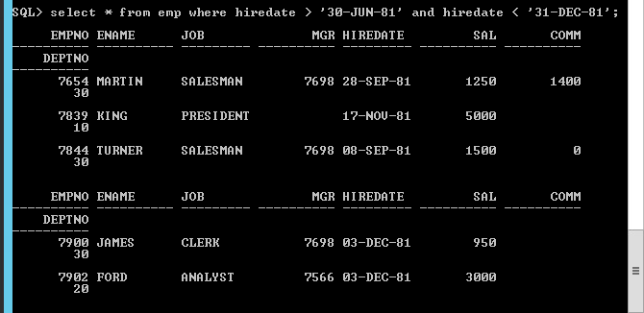

1. List the different designations available in the company

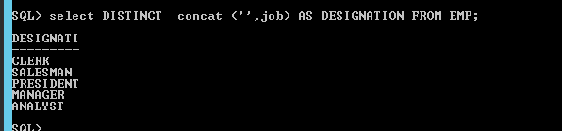

1. List those employees name that are not eligible for commission

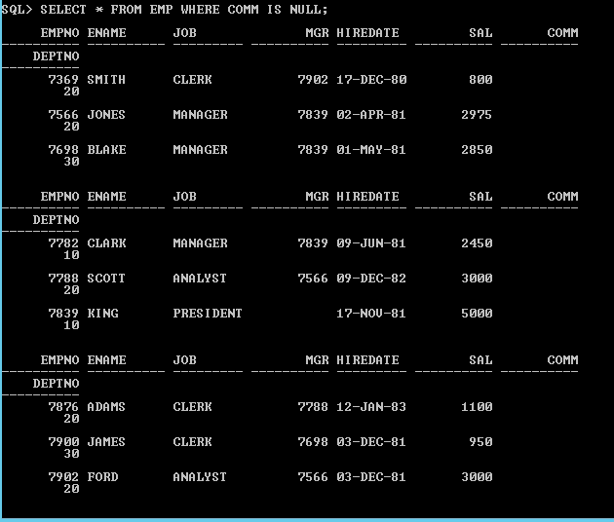

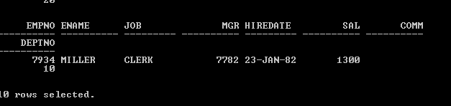

1. List the name of the employee and designation of the employee who does not report to anybody



1. List the employees who are eligible for commission

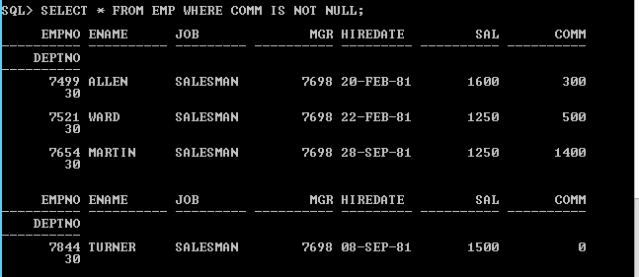

1. List names of employees if the names have “i” as the second character



1. Display the names of all employees with their salary and commission earned. Employees with a null commission field should have 0 in the commission column

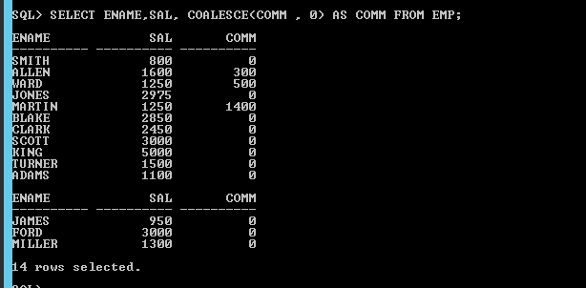

## Round 2 – Group by clause

Write queries for the following questions

1. List the count and average salary for employees in department 20.



1. List names of employees who are older than 30 years in the company.



1. List the employee name , hire date in the descending order of the hire date.

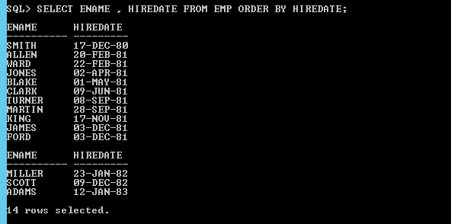

1. List employee name, salary, PF, HRA, DA and gross; order the results in the ascending order of gross. HRA is 50% of the salary and DA is 30% of the salary.

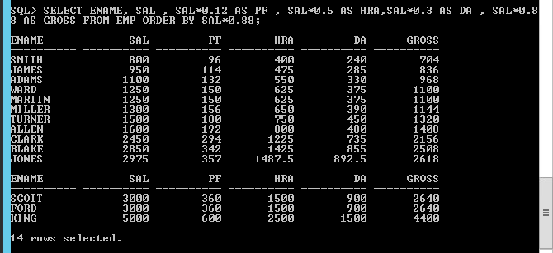

1. List the department numbers and number of employees in each department.



## Round 3 – SUBQUERIES

Write queries for the following questions

1. List employees whose job is same as that of Smith

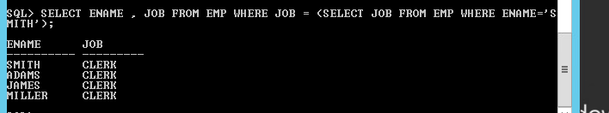

1. List employees who have joined after Adam

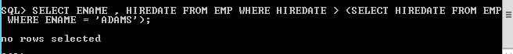

1. List employees who salary us greater than Scott’s salary

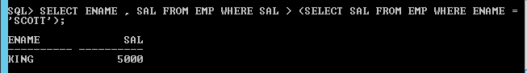

1. List employees getting the max salary

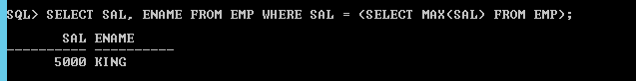

1. List employees show salary is > the max salary in deptno 30

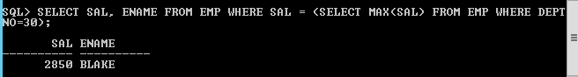

## Round 4 – Joins (Mortal mode)

1. List employee name, department number and their corresponding department name.

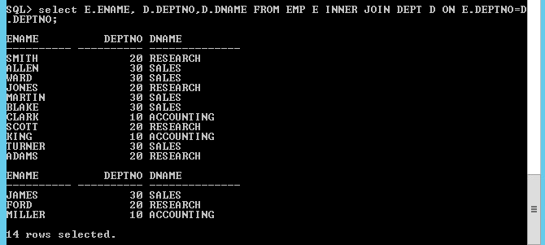

1. List employee name and their manager name

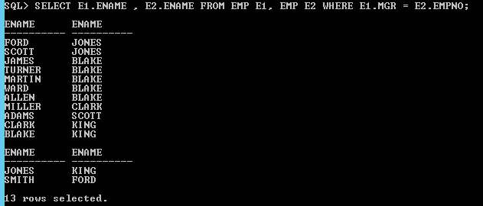

1. List employees who work in Research department

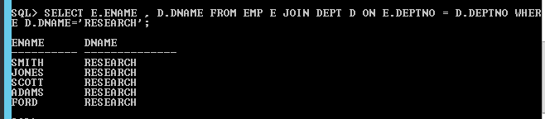

1. List all rows from EMP table and only the matching rows from DEPT table.

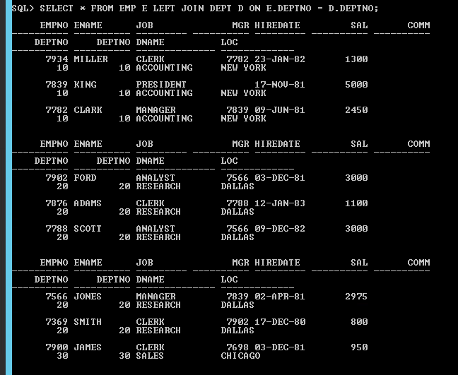

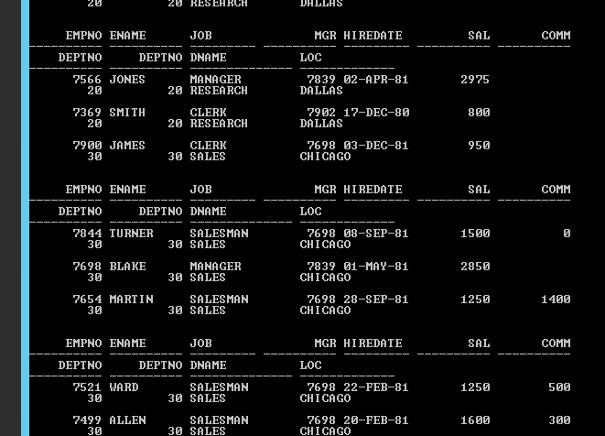

1. List all rows from EMP table and only the matching rows from DEPT table.



